**Pulmonary inflammatory response and immunomodulation to multiple trauma and hemorrhagic shock in pigs**

**- Original uncropped and unadjusted images underlying western blot results -**

Marc-Alexander Oestreich, Kerstin Seidel, Wilhelm Bertrams, Hans-Helge Müller, Martin Sassen, Thorsten Steinfeldt, Hinnerk Wulf, Bernd Schmeck

Caspase-3 Western blot pattern

|  |  |  |  |  |  |  |  |  |  |  |  |  |  |  |  |  |  |  |  |  |  |  |  |  |
| --- | --- | --- | --- | --- | --- | --- | --- | --- | --- | --- | --- | --- | --- | --- | --- | --- | --- | --- | --- | --- | --- | --- | --- | --- |
| **Gel #1** | | | | | | | | | | | | | | | | | | | | | | | | |
| **1** | **2** | **3** | **4** | **5** | **6** | **7** | **8** | **9** | **10** | **11** | **12** | **13** | **14** | **15** | **16** | **17** | **18** | **19** | **20** | **21** | **22** | **23** | **24** | **25** |
| Laemmli-buffer (30 µl) | Laemmli-buffer (30 µl) | **Marker** (5µl) | Neg-CTRL (2,5 µl) | Pos-CTRL (2,5 µl) | #10 | #22 | #4 | #18 | #3 | #8 | #11 | #7 | #9 | #13 | #43 | #44 | #47 | #42 | #45 | #46 | **Marker** (5µl) | Laemmli-buffer (30 µl) | Laemmli-buffer (30 µl) |  |

|  |  |  |  |  |  |  |  |  |  |  |  |  |  |  |  |  |  |  |  |  |  |  |  |  |
| --- | --- | --- | --- | --- | --- | --- | --- | --- | --- | --- | --- | --- | --- | --- | --- | --- | --- | --- | --- | --- | --- | --- | --- | --- |
| **Gel #** | | | | | | | | | | | | | | | | | | | | | | | | |
| **1** | **2** | **3** | **4** | **5** | **6** | **7** | **8** | **9** | **10** | **11** | **12** | **13** | **14** | **15** | **16** | **17** | **18** | **19** | **20** | **21** | **22** | **23** | **24** | **25** |
| Laemmli-buffer (30 µl) | Laemmli-buffer (30 µl) | **Marker** (5µl) | Neg-CTRL (2,5 µl) | Pos-CTRL (2,5 µl) | #35 | #36 | #17 | #19 | #15 | #20 | #21 | 24 | #48 | #55 | #49 | #50 | #53 | **Marker** (5µl) | Laemmli-buffer (30 µl) | Laemmli-buffer (30 µl) |  |  |  |  |

|  |  |  |  |  |  |  |  |  |  |  |  |  |  |  |  |  |  |  |  |  |  |  |  |  |
| --- | --- | --- | --- | --- | --- | --- | --- | --- | --- | --- | --- | --- | --- | --- | --- | --- | --- | --- | --- | --- | --- | --- | --- | --- |
| **Gel #3** | | | | | | | | | | | | | | | | | | | | | | | | |
| **1** | **2** | **3** | **4** | **5** | **6** | **7** | **8** | **9** | **10** | **11** | **12** | **13** | **14** | **15** | **16** | **17** | **18** | **19** | **20** | **21** | **22** | **23** | **24** | **25** |
| Laemmli-buffer (30 µl) | Laemmli-buffer (30 µl) | **Marker** (5µl) | Neg-CTRL (2,5 µl) | Pos-CTRL (2,5 µl) | #37 | #41 | #38 | #40 | #23 | #30 | #31 | #26 | #32 | #33 | #39 | #57 | #60 | #61 | **Marker** (5µl) | Laemmli-buffer (30 µl) | Laemmli-buffer (30 µl) |  |  |  |

Protein concentrations were determined using the Pierce BCA protein assay kit (Thermo Fisher Scientific, Rockford, IL, USA). Equal amounts of protein (60 µg) were separated in 15% Tris-HCl SDS-polyacrylamide gels for semi-dry blotting of caspase-3 with 0.003 mA/cm² on PVDF membranes. Prior to incubation with antibodies, the blots were cut horizontally along 38 kDa to enable simultaneous analysis of ß-actin (40 kDa), pro-caspase-3 (32 kDa) and cleaved caspase-3 subunits (11, 17, 20 kDa), washed and blocked (3% bovine serum albumin in TBS-T20). The chemo-luminescent signals were captured using a Gel-x imager system (Intas Science Imaging Instruments, Göttingen, Germany), quantified by densitometry (ImageJ 1.52j, National Institutes of Health, USA) and normalized to ß-actin. Untreated and cytochrome c-treated Jurkat control cell extracts (#9663, Cell Signaling Technology, Frankfurt, Germany) served as controls

Left upper lobe (contralateral control): ß-actin

\\filer300\users3006\i0324531\Documents\PROMOTION Marburg\Manuscript\Submission to PLOS One\Western Blot_Casp 3\L1\L1_beatactin_inv_8bit.tif

Left upper lobe (contralateral control): Caspase-3

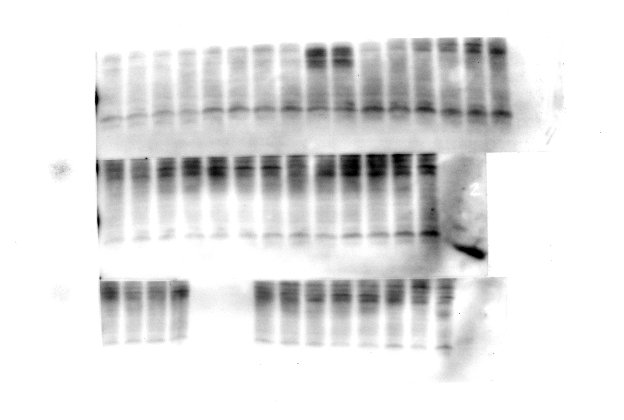

Right upper lobe (ipsilateral control): ß-actin

C:\Users\i0324531\AppData\Local\Microsoft\Windows\INetCache\Content.Word\R1+R2_actin_inv_8bit.tif

Right upper lobe (ipsilateral control): Caspase-3

C:\Users\i0324531\AppData\Local\Microsoft\Windows\INetCache\Content.Word\R1_casp-3-subunits_inv_8bit_28082016.tif

Right lower lobe (contusion site): ß-actin

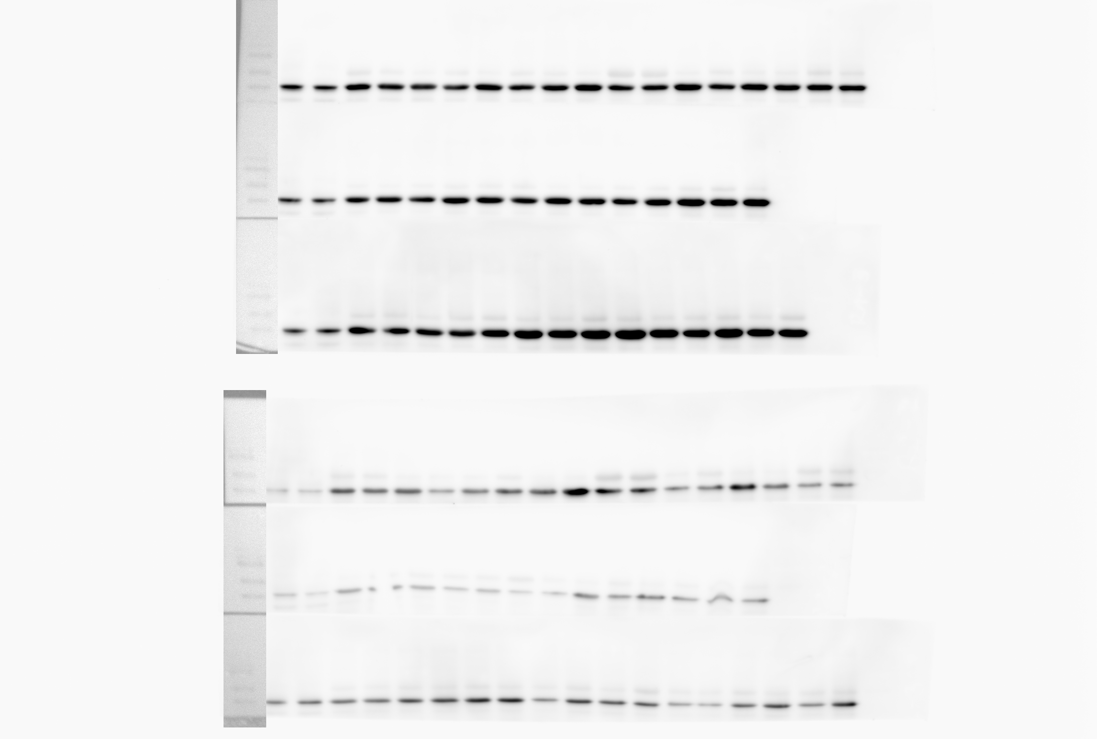

Right lower lobe (contusion site): Caspase-3

C:\Users\i0324531\AppData\Local\Microsoft\Windows\INetCache\Content.Word\Procaspas 1mi 15scan 07102016,15-15_inv_8bit.tif